Answer for Software Engineering Exam (A)
2004.12

Part 1. Selection (27 marks, 1 mark for each selection)

1. A
2. B
3. B
4. ① B ② C
5. ① A ② E
6. ① D ② C ③ A ④ E ⑤ B
7. C
8. D
9. ① B, ② C
10. C
11. ① B, ② G, ③ A, ④ H, ⑤ D, ⑥ G
12. C
13. ① C, ② A, ③ B

Part 2 Filling (20 marks, 1 mark for each filling)

1. ①requirement, ②specification, ③design, ④implementation, ⑤integration, ⑥ maintenance, ⑦ retirement
2. rapid prototype
3. risk
4. ① client, ② developers, ③ user
5. message
6. Maintenance
7. ① sequence ② collaboration
8. ① construct interaction diagrams for each scenario
② construct the detailed class diagram
③ design the product in terms of clients of objects
④ proceed to the detailed design

Part 3 Judgment (6 marks, 1 mark for each item)

1. T
2. T
3. F
4. T
5. F
6. F

Part 4 Question (7 marks)

(1) (1 mark) The reason for the limited success of the structured paradigm is that the structured techniques are either action oriented or data oriented but not both. In contrast, the object-oriented paradigm considers both data and actions to be equally important. A simplistic way of looking at an object is as a unified software component that incorporates both the data and the actions that operate on the data.
(2) (1 mark) The payoff that the implementation details are local to an object comes during maintenance. Object-oriented paradigm makes maintenance quicker and easier, and the chance of introducing a regression fault is greatly reduced.
(3) (1 mark) Object-oriented paradigm makes development easier. The close correspondence between the objects in a product and their counterpart in the real world promotes better software development.
(4) (1 mark) Well-designed objects are independent units. An object consists of both data and the actions performed on the data. If all the actions performed on the data of an objects are included in that object, then the object can be considered a conceptually independent entity. Everything in the product can be found in the object itself. This is an additional form of independence is termed encapsulation. In a well-designed object, information hiding ensures that implementation details are hidden from everything outside that object. The only allowable form of communication is the sending of a message to the object to carry our a specific action. The way that the action is carried out is entirely the responsibility of the object itself.
(5) (1 mark) A product built using the structured paradigm essentially is a single unit. This is one reason why the structured paradigm has been less successful when applied to larger products. In contrast, then the object-oriented paradigm is used correctly, the resulting product consists of a number of smaller, largely independent units. The object-oriented paradigm reduces the level of complexity of a software product and hence simplifies both development and maintenance.
(6) (1 mark) Object-oriented paradigm promotes reuse. Because objects are independent entities, they can be utilized in future products. This reuse of objects reduces the time and cost of both development and maintenance.
(7) (1 mark) When object-oriented analysis is used, objects enter the life cycle form the very beginning. The objects are extracted in the analysis phase, designed in the design phase, and coded in the implementation phase. Thus, the object-oriented paradigm is an integrated approach; the transition from phase to phase is far smoother than with the structured paradigm, thereby reducing the number of faults during development.

Part 5 Case Analysis and Design (40 marks)

- Use-case diagram （10 marks）

Grading standard:
- 3 marks for the actors
- 3 marks for the first 3 cases
- 4 marks for the 8 more cases

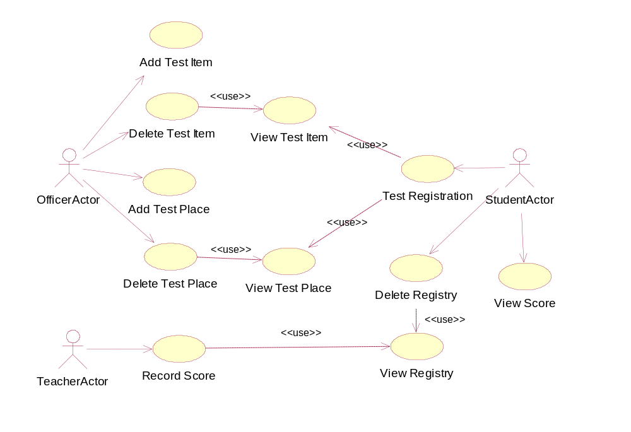

- Detailed class diagram （15 marks）

Grading standard:
- 7 marks for the basic class structure
- 4 marks for the attributes
- 4 marks for the attributes

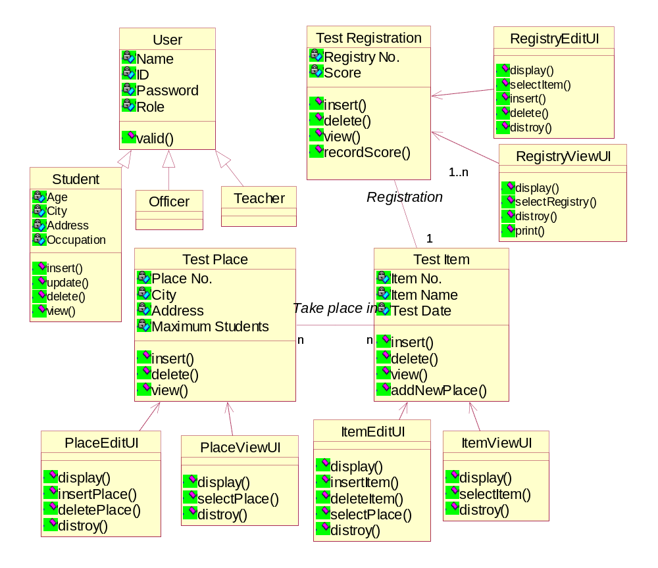
- Sequence diagram （15 marks）

  - Item Administration (4 marks)

Grading standard:
    - 1.5 marks for the objects
    - 2.5 marks for the sequences
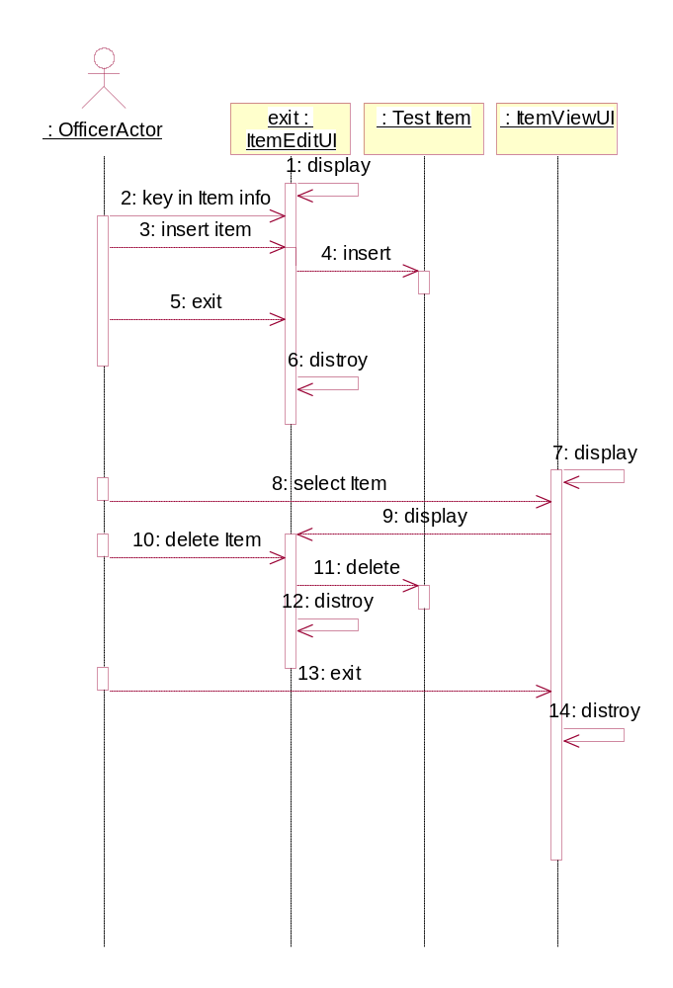

  - PlaceAdministration (4 marks)

Grading standard:
    - 1.5 marks for the objects
    - 2.5 marks for the sequences
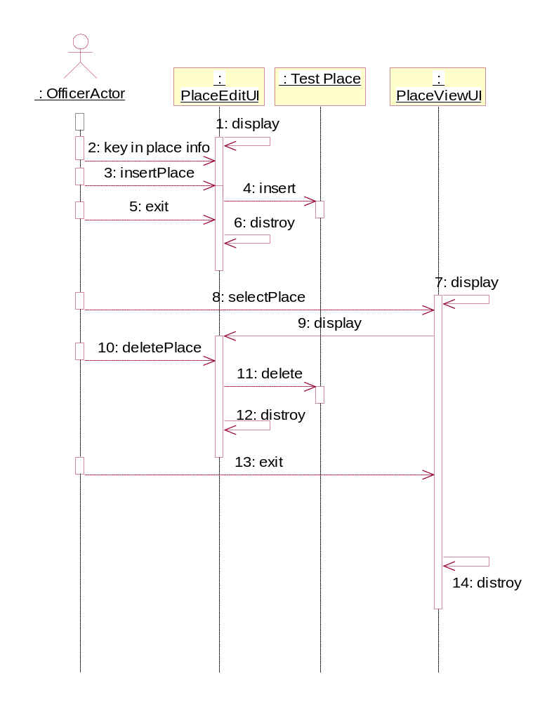

  - Test Record Score (4 marks)

Grading standard:
    - 1.5 marks for the objects
    - 2.5 marks for the sequences
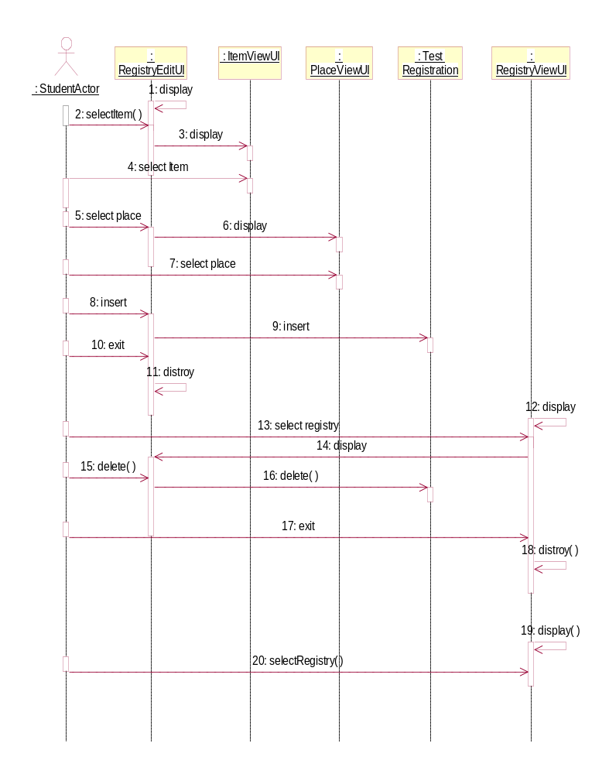

  - Test Registration (3 marks)

Grading standard:
    - 1 mark for the objects
    - 2 marks for the sequences

